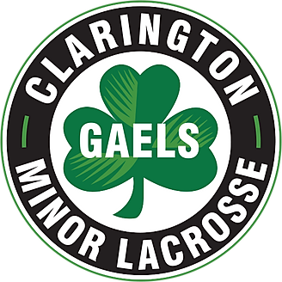
CLARINGTON MINOR LACROSSE ASSOCIATION

2024 Coach courses Required – all course found at coach.ca and in your Locker

Required Coach and Volunteer Training

All course can be found at www.coach.ca and in your Locker

- Making Ethical Decisions
- Making Headway in Sport
- NCCP Emergency Action Plan – trainers must take this
- Safe Sport Training – Decision Makers
- Safe Sport Training – Direct Athlete Contact
- Safe Sport Training – No Direct Athlete Contact
- Understanding the Rule of Two
- NCCP – Coach Initiation in Sport - $15 covered by team budgets

