**HYDRATION**

1. Hydration is cumulative so make it a habit – it adds up
2. 2 days before a practice or game
   1. Breakfast – 1 large glass of water
   2. Lunch – 1 large glass of water
   3. Dinner – 1 large glass of water
   4. Between meals 2 large glasses of water
3. 1 day before the practice or game
   1. Breakfast – 1 large glass of water
   2. Lunch – 1 large glass of water
   3. Dinner – 1 large glass of water
   4. Between meals 2 large glasses of water
4. Day of the practice or game – depending on when the practice or game is
   1. Breakfast – 1 large glass of water
   2. Lunch – 1 large glass of water
   3. Dinner – 1 large glass of water
   4. Between meals 2 large glasses of water

**Maximize your fluid intake in the 24 hours before the game**

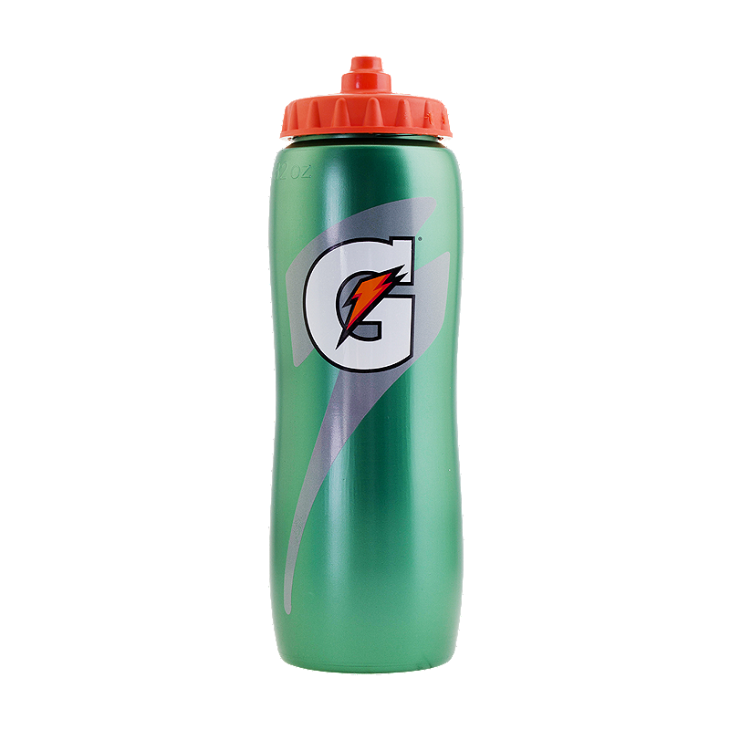

**SIGNS OF DEHYDRATION**

Noticeable thirst, muscle cramps, weakness, decreased performance, nausea

headaches, dry mouth, fatigue, lightheaded feeling or dizziness, difficulty

paying attention and decreased urine output and dark yellow in colour

**TREATMENT**

Rest in a cool place and monitor person

Consume a sports drink that contains an adequate amount of electrolytes (sodium,

chloride, potassium, calcium and magnesium)

Call 911 if no improvement occurs

Prevent dehydration in the future by consuming fluids before, during and after

**Minimum fluid needs equal half of your body weight in ounces**

**150 lbs. = 2 liters of fluid minimum**

**REHYDRATION**

**Replace every pound you lose with ¾ of liter of fluid and 1 gram of salt**

**e.g. 150 lb. athlete loses 4 lbs. during a workout**

**Minimum daily fluid needs = 2 liters**

**Fluid needs to replace sweat lost = 2 ¼ liters**

**Total fluid needs = 4 ¼ liters per day**

**SPORTS DRINKS AND WATER ARE GOOD REHYDRATION FLUIDS**

**DO NOT DRINK ENERGY DRINKS FOR REHYDRATION**

**HYDRATION**



**PRE GAME OR PRACTICE**

1. Eat a meal 2 to 4 hours before a game

2. Meal should be high in carbohydrates, moderate in protein, lower in fat and moderate in size

3. Carbohydrates are the key to pre-game meals – they will be stored energy and used during the game

- 100 % whole wheat bread, brown rice, bran cereals and oatmeal are good

because they will provide longer lasting energy

- potatoes and quinoa – sweet potatoes are better

- dairy products, beans and fruits are good also

- frozen yogurt instead of ice cream

- red sauce instead of alfredo sauce

- plain bread better than garlic bread

- jam or honey is better than cream cheese and butter

- energy bars

- peanut butter and jelly sandwiches

- apples, bananas and oranges

**30 – 60 minutes before the game drink more liquids and have a carb-based snack**

**- energy bar, granola bar, fruit, pretzels**

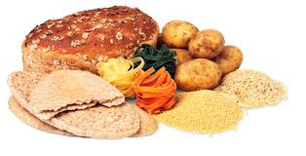

**FOOD TO PACK FOR GAMES**

* greek yogurt and fruit – nonfat or low-fat
* trail mix – peanuts, cashews, dried fruit, chocolate bits, seeds, goji berries, almonds, cacao nibs
* fruit and low fat cheese
* low fat chocolate milk
* fig or date bars
* peanut butter sandwich
* pistachios and other nuts

**Information taken from USA Lacrosse, Live Strong and Canada Food Guide**



**RECOVERY NUTRITION – POST EXERCISE, PRACTICE AND GAME**

**HOW MUCH TO EAT FOR RECOVERY**

1. Target carbohydrate intake should be 0.5 grams per pound of body weight

150 lbs. = 75 grams

2. 75 grams should be eaten within the first hour post exercise

3. Can be split into small snacks 15-30 minutes

4. Check the nutrition facts panel on the food items

**PROTEIN FOR RECOVERY**

Protein helps repair the damaged muscles and build new fibers for muscle growth.

Carbohydrate and Protein foods for recovery

+ Chocolate milk

+ Cereal with milk

+ Granola with yogurt

+ Apple, banana and orange

+ Trail mix with nuts, dried fruit and chocolate

+ Peanut butter and jelly sandwich

+ Pretzels and hummus

**POST EXERCISE NUTRITION**

Recovery Nutrition begins immediately after practice or games and continues for

4 to 6 hours.

Primary goals are to replenish energy stores and repair muscles.

**High carbohydrate recovery foods**

* bagel, pasta, rice, bread, fruit, crackers, cereal, granola, potatoes, smoothies,

juice, sport drink

**High Quality Protein**

* Chicken – 25 g in 3 oz.
* Beef – 24 g in 3 oz.
* Fish – 20 g in 3oz
* Non-fat yogurt – 11 gin 8 oz.
* Milk – 8 g in 1 cup
* Egg - 7 g in1 large egg

- Quinoa – 1 cup

