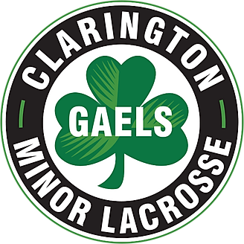
CLARINGTON MINOR LACROSSE ASSOCIATION

2024 Coach courses Required – all course found at coach.ca and in your Locker

ONTARIO LACROSSE CODE OF CONDUCT

Section I – All individuals affiliated with the OLA shall:
I. Attempt at all times to work toward the goals and objectives of the OLA and the game of Lacrosse, and towards the betterment of its members.
II. Strive to heighten the image and dignity of the Association and the sport of Lacrosse as a whole, and to refrain from behaviour which may discredit or embarrass the Association or the game.
III. Always be courteous and objective in dealing with other members.
IV. Strive to achieve excellence in the sport while supporting the concepts of Fair Play and Drug free sport.
V. Show respect for the culture, social and political values of all participants in the sport.
VI. As a guest in another province or foreign country, abide by the laws of the host jurisdiction and adhere to any social customs concerning conduct.
Section II – An Individual’s conduct shall be in question when they:
I. Breach any of the above Section 1.
II. Use their position within the OLA for unauthorized personal and/or material gains.
III. Willfully circulate false, malicious statements, derogatory to any other member of the Association.
IV. Willfully ignore or break the Bylaws, policies and/or rules and regulations of the OLA.
V. Counsel others to ignore or break the bylaws, policies, and/or rules and regulations of the OLA.
Section III – General:
I. The OLA endorses the principles of natural justice and due process which allows any individual the right to a hearing and an appeal of any action which affects their rights.
II. The OLA and its member governing bodies agree to honor and enforce disciplinary action taken by those governing bodies upon the completion of due process.
Section IV – Discipline Procedures:
I. Any report alleging a breach of Member obligation under this Code of Conduct shall be submitted in writing to the OLA within fourteen (14) days of the event/occurrence.
II. Upon receiving a report, the OLA staff shall immediately notify the OLA Executive who shall determine the merit of the complaint and determine if action is necessary.
III. If action is deemed necessary, the event/occurrence will be dealt with under normal OLA Discipline and Appeals procedures.

Signature of Coach _____________________________ Date _____________________

